

|  |  |  |
| --- | --- | --- |
| Mathematics Department | |  |
| Course: A1MAA | |
| Topic Title: Test 2 – Calc Free | |
| Student Name:_____________________________________ | Date: ____________ | | |
| Special Instructions: Formula Sheet Allowed | Time Allowed: | | |
|  | Marks: / 27 | | |

**Question 1. (2 marks)**

Using the formula v = u + at, calculate v given: u =16, a =0.5 and t = 15

**Question 2. (2, 2 : 4 marks)**

If $x = 2$, $y= -3$, and $z = -5$, then find the values of:

a) $5x^{2}$ b) $\frac{x-y}{yz}$

**Question 3. (1,1,1 : 3 marks)**

If emn is the element situated in the mth row and nth  column of matrix E determine

a) e33 b) e21 c) f12

where matrices E and F are as given below.

**E = 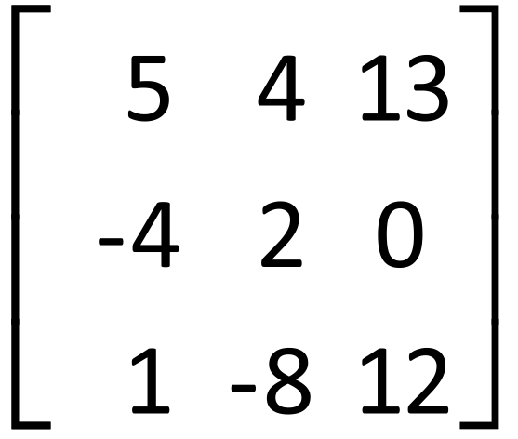 F =** 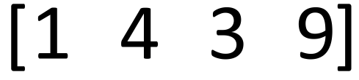

**Question 4. (2,2,2,2,2,2:12 marks)**

If **A = 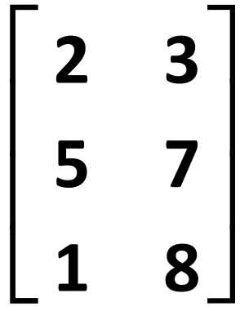 B = 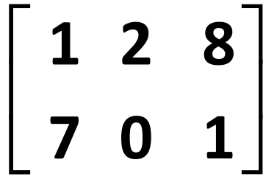 C = 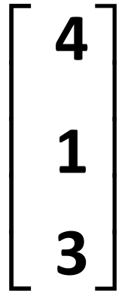 D = 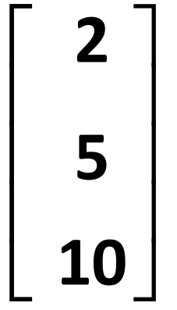 E =** 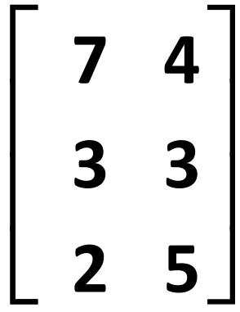

determine each of the following. If any cannot be determined state this clearly and explain why

a) *E + A* b) 3*B*

c) 2*D - C* d) *BD*

*e) CE f) A2*

**Question 5. (1,3,2 : 6 marks)**

Give matrices to fit the following descriptions.

a) A row matrix with 3 columns (using any values)

b) A square matrix *A* in which there are 2 rows and amn = m + n

c) Tickets to an exhibition are cheaper on weekdays than weekends. Adult tickets are $15 on

weekdays and $20 on weekends. Student tickets are $10 on weekdays and $12 on weekends.